**Advance Excel Assignment 1**

*1. What do you mean by cells in an excel sheet?*

1. A cell is an essential part of MS-Excel. It is an object of Excel worksheets.
2. In the Excel worksheet, a cell is a rectangular-shaped box. It is a small unit of the Excel spreadsheet.
3. There are around 17 billion cells in an Excel worksheet, which are united together in horizontal and vertical lines.
4. Excel allows the user to enter any type of data in Excel cells, such as numeric, text, date, and time data. Whatever you enter in a cell, it appears inside the cell and as well as in the formula bar.
5. To enter the data/information into a cell, double-tap on any cell to make it editable and write the data in it.
6. Select the cell along with data inside it and either press Backspace or Delete button to delete the content of the cell.

*2. How can you restrict someone from copying a cell from your worksheet?*

By entering the password, one can secure his worksheet from getting copied by others*.*

Follow these steps to lock cells in a worksheet:

1. Select the cells you want to lock.
2. On the Home tab, in the Alignment group, click the small arrow to open the Format Cells popup window.
3. On the Protection tab, select the Locked check box, and then click OK to close the popup.
4. On the Review tab in the ribbon, in the Changes group, select either Protect Sheet or Protect Workbook, and then reapply protection. See Protect a worksheet or Protect a workbook.

*3. How to move or copy the worksheet into another workbook?*

Below are the steps to move or copy a sheet to another workbook on a PC:

1. Open both spreadsheets.
2. Right-click on the sheet you want to move.
3. Click “Move or Copy.”

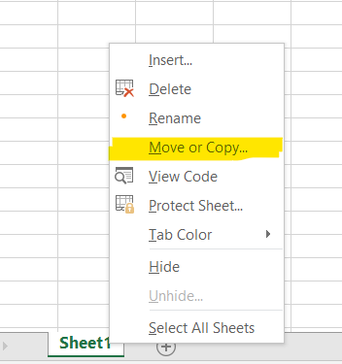

1. Click on the “To book” dropdown menu and find the workbook you want this sheet to move to.

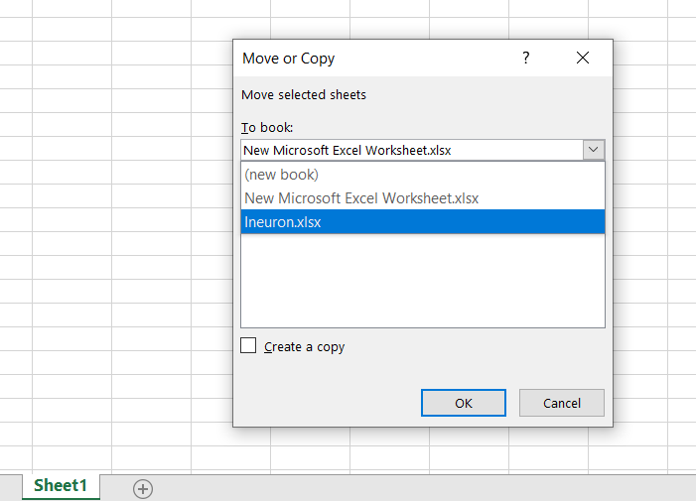

1. Select the “Create a copy” checkbox at the bottom of the window to copy the sheet else it will move to the workbook selected.
2. Click “OK.”
3. This will move/copy the sheet to another workbook.

Another method is open the both workbooks and select the worksheet which required to move or copy and drag on the another excel workbook. Hold control button to copy the same.

*4. Which key is used as a shortcut for opening a new window document?*

Ctrl+N

Tip: To quickly create a new blank file or email, press Ctrl+N.

*5. What are the things that we can notice after opening the Excel interface?*

Below things we can notice after opening the Microsoft Excel Window:

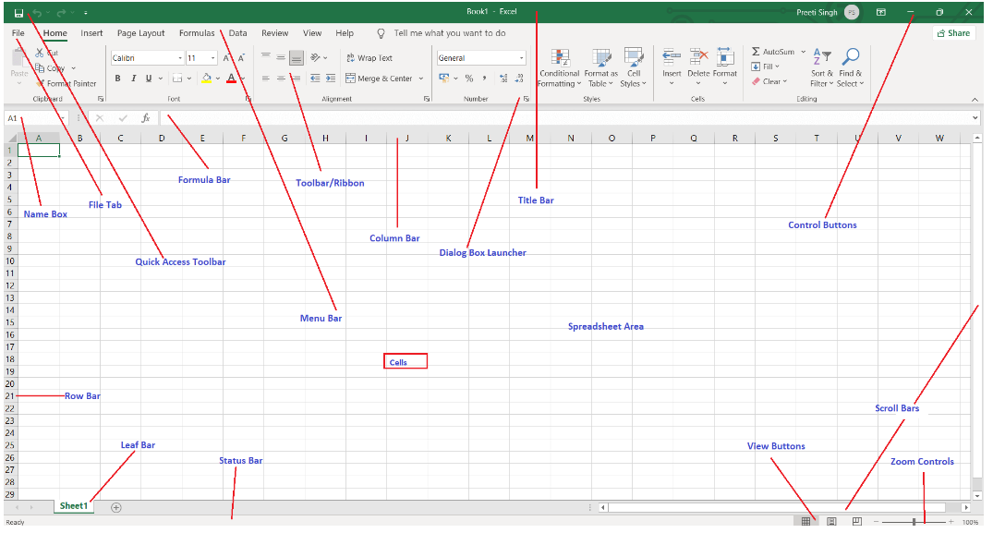

1. Quick Access Toolbar
2. File Tab
3. Title Bar
4. Control Buttons
5. Menu Bar
6. Ribbon/Toolbar
7. Dialog Box Launcher
8. Name Box
9. Formula Bar
10. Scroll Bars
11. Spreadsheet Area
12. Leaf Bar
13. Column Bar
14. Row Bar Cells
15. Cells
16. Status Bar
17. View Buttons
18. Zoom control

*6. When to use a relative cell reference in excel?*

1. Relative reference is a type of cell reference in Excel. This reference changes when the formula is copied to any other cell or any other worksheet.
2. Relative cell references are used whenever calculations need to be repeated.
3. By default, a cell reference is a relative reference, which means that the reference is relative to the location of the cell.
4. for example, you refer to cell A2 from cell C2, you are actually referring to a cell that is two columns to the left (C minus A)—in the same row (2). When you copy a formula that contains a relative cell reference, that reference in the formula will change.
5. When we have to repeat a calculation across numerous rows or columns, relative references are extremely useful.